**COMSATS UNIVERSITY ISLAMABAD**



**SUBMITTED BY:**

**MARYAM MUKHTAR**

**REGISTRATION NO:**

**FA24-BBA-123**

**SUBMITTED TO:**

**PROF. MUFEEZA MANZOOR**

**ASSIGNMENT TITLE:**

**EXERCISE NO. 2**

**DEADLINE DATE:**

**OCTOBER 22nd, 2025**

**EXERCISE QUESTION’S ANSWERS:**

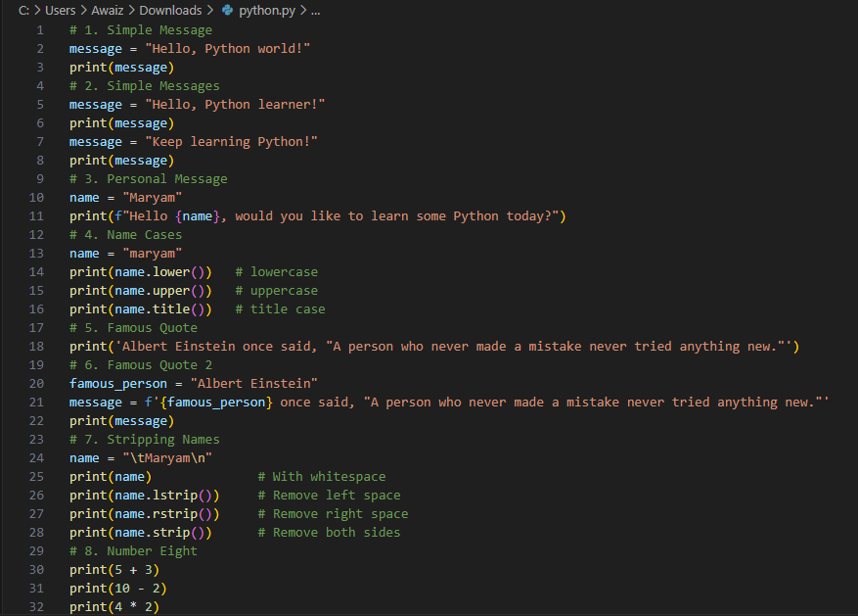

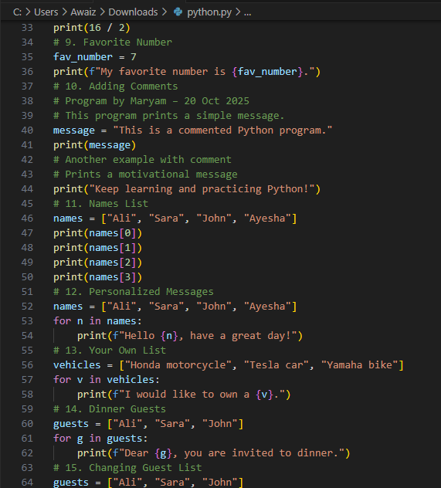

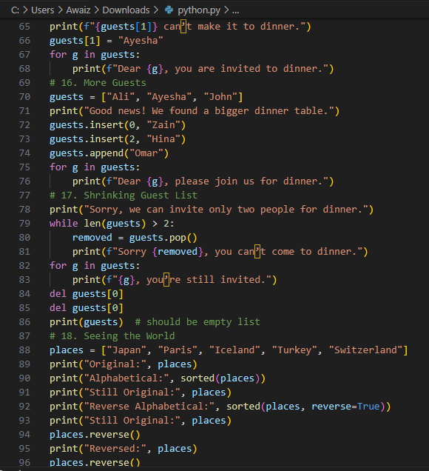

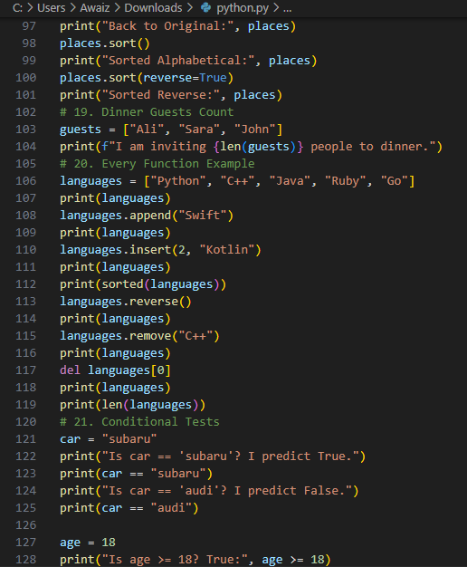

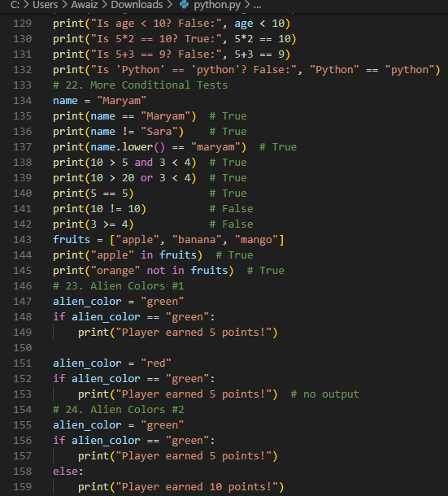

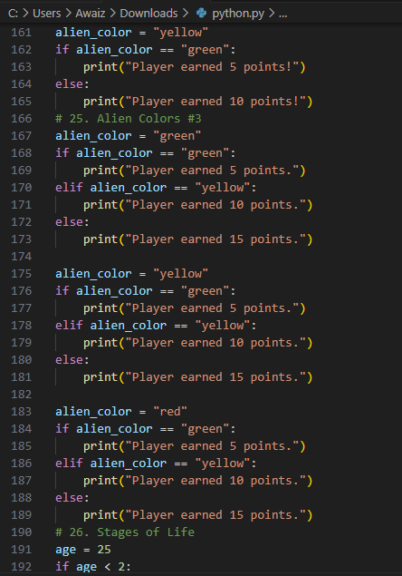

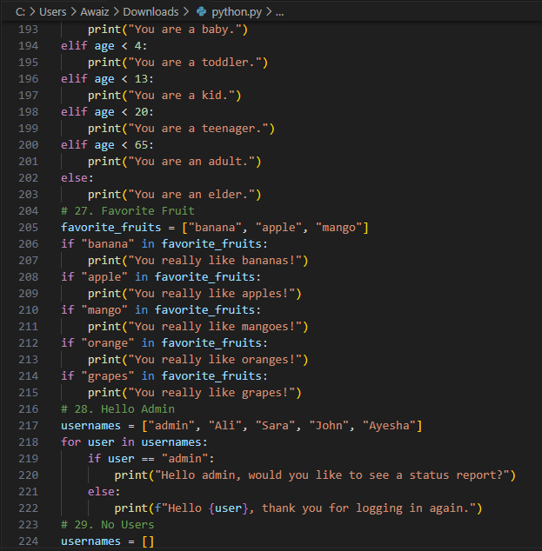

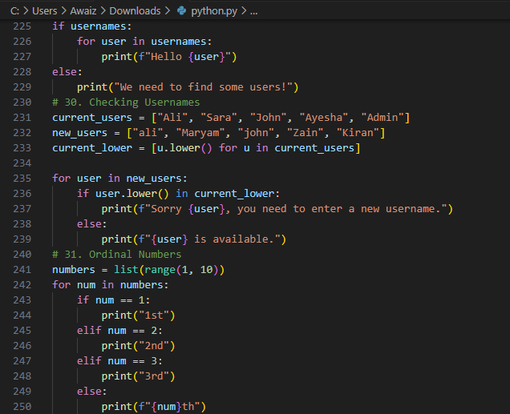

**OUTPUTS :**

